St. Aldhelm’s Church Primary School



PARENTS GUIDE TO:

Free School Meals

ELIGIBILITY FOR FREE SCHOOL MEALS

Many of our pupils currently receive free school meals but we believe that there may be many more pupils who are entitled to them, but who do not claim them. This may be for a variety of reasons. In order to qualify for free school meals, parents need to be claiming one or more of the following benefits:

Income Support, Income Based Jobseekers Allowance, Income Based Employment Support Allowance or Child Tax Credit (but not working tax credit).

Annual income must not be more than £16,190

If you think that your child may be entitled to free school meals, you can apply by contacting the school office. To claim you just have to fill out a short form.

Our school office team are helpful, friendly and always totally confidential and will support you with any aspect of the process. You could be saving £10 per week

It is a really good idea to claim free school meals, even if your child would prefer not to have them. This is because your child’s name would then be registered and we can contact you with regard to other entitlements or schemes as they become available.

We can only inform you of new schemes and grants if your child is registered as eligible for free school meals, so please have a chat with one of our office staff in confidence if you receive any of the benefits listed.

Infant Free School Meal Scheme

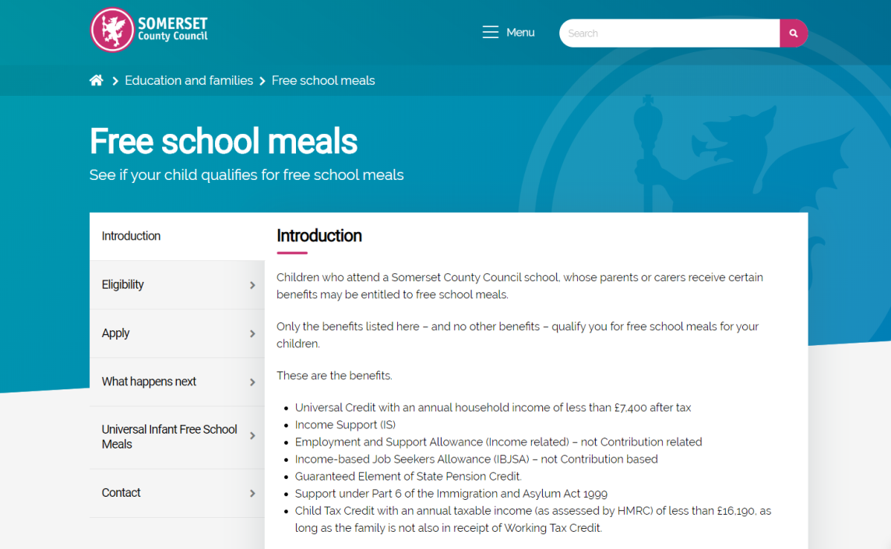
From 1st September 2014 all children in Reception, Year One or Year Two are entitled to a free school meal every day.

This is a new government initiative launched to ensure a quality, hot school meal daily for children up to 7 years of age.

To register your child for their free daily school meal please ask for an ‘Infant Free School Meal’ form from the school office or complete the online application form at https://www.somerset.gov.uk/education-and-families/free-school-meals/

