Dear Year 4 Owl Parents,


Welcome back to St Aldhelm’s and to Owls! Again, I hope you have all had a lovely summer together and enjoyed the wonderful weather. I am really excited about the year ahead and working with yourselves and your children to ensure that Year 4 learning is even more fun, engaging and exciting! Knowing yourselves and the children already, routines and expectations can be very quickly established so that this can happen successfully.

The team
I will teach the class every day. Mrs Bayley will support on Tuesdays, Wednesdays and Thursdays and Mrs Manship will be teaching the class for PPA (Planning, Preparation and Assessment) time on a Thursday afternoon, alongside an Evolve Sport P.E. session to help further build teamwork and resilience skills. I will work closely with Mrs Manship to ensure that handover planning and assessment information is shared and also that the subjects are rotated throughout the year.

Owl projects

We have some great enquiry projects this year, as you will soon see on the Long-Term Plan on the class webpage. We are going to begin with looking at ‘Europe: Italy and Rome’. Our English written work is going to begin with a narrative focus, using ‘The Lion and the Unicorn’ by Shirley Hughes as our class book. In maths, we will start the term by again assessing and developing Place Value skills. This includes partitioning numbers in different ways, rounding and using Roman numerals!

Uniform
It is important that, once again, the children in Owls set a good example to younger children in the school. Please ensure that your child is wearing appropriate clothing and footwear. For those children who have their ears pierced, these need to be plain studs which will need to be removed or covered with tape for PE lessons. The only jewellery required is a watch or medic alert bracelet. Children with longer hair should have their hair tied back. There is more information on the school website regarding uniform should you need to check further.

PE

Owls will have PE on a Wednesday and Thursday and we will begin, as last year, with yoga! I will let you know when I have further information about the Evolve Sport sessions and I’ll ensure that as many photos as possible are regularly put onto Class Dojo. The children will need to wear their school PE kit to school for these days (plain white t shirt, black PE shorts and black daps). Sometimes we may have these PE lessons outside if the weather allows, so please also provide a dark coloured track suit or dark joggers and a sweatshirt. We will aim to use the outdoors in our learning throughout the year whenever possible so please could children also bring a pair of wellies to be kept in school, as well as a coat.

Meetings
Strong communication and links are important and valued within our school community. Class Dojo messages, emails and messages through the school office are the main ways of maintaining these strong links. This ensures that I can focus on maintaining the safety of the children at the end of the school day and through transitional periods. Phone calls or meetings can be arranged should you wish to discuss an issue, concern or enquiry further and I will be happy to do so at a convenient time for both parties.

Home learning

I am looking forward to continuing the strong partnership between us, which has and will continue to result in your child’s learning journey being successful. It is strongly encouraged that you support your child at home by practicing reading, spelling, maths and enquiry skills. Your support at home is vital in making a difference to your child’s development. Home learning will be set each week, unless otherwise stated, on a Wednesday and will need to be completed and shared by the following Tuesday. This will look slightly different this year to make things even more fun, engaging and exciting- more information will come your way in Week 3.
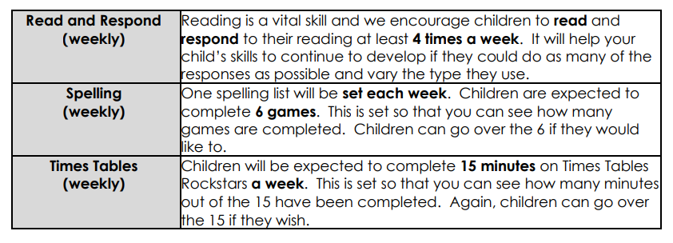

There will be an opportunity to meet with me on Wednesday 23rd September after school, for any parents that I didn’t see last year or if you have any questions about anything detailed here. Thank you in advance for your support and I’m looking forward to working with you all again in 2026-27!

Kind regards,
Mr Mike Powell

