Owls Home Learning Project Autumn Term 1
We are trialling a pick ‘n’ mix project for home learning! I’m hoping that the children will enjoy the element of choice and this is also used higher up the school too. The children will have a fortnight (two weeks) per project and at the end of the term, they will select one they wish to share with the class or a small group. This adds further purpose to their learning as they develop their speaking and listening skills, as well as helping others to learn what they have. These will be handed in on a Tuesday morning, every other week.

Geography / DT  Create a diorama / model on a chosen habitat. Think carefully about what you want your model to show us.  Can you show the relationship between different animals?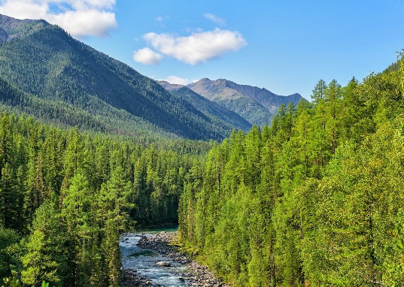 | Writing  Create a piece of descriptive writing based on this image from our class book, ‘The Lion and The Unicorn’.  Can you use all 5 senses in your writing?  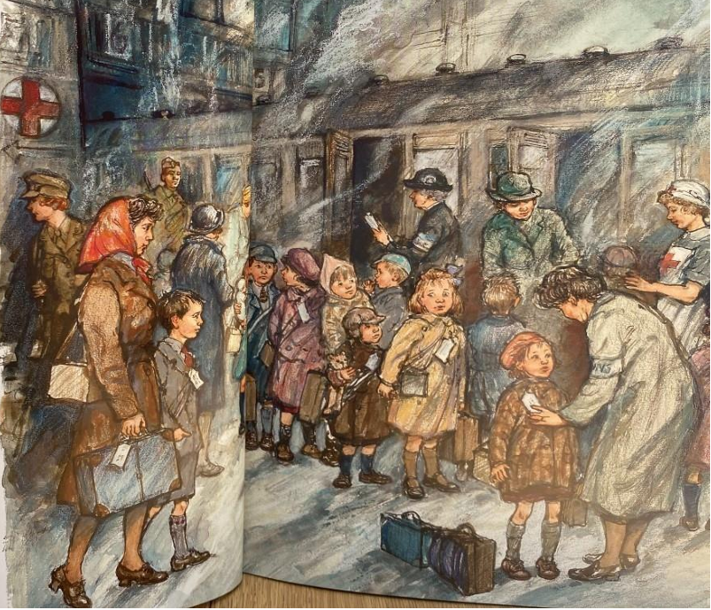
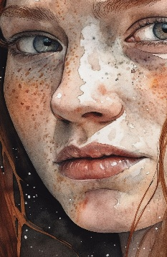  Art  Create a portrait of a person that inspires you. What it is that interests and excites you about them? | Reading    Create a book review on a story of your choice. Why are you recommending it to other people? |   Geography / PSHE  Share about the importance of habitats for our planet and what is harming them. What do you think we can do to save the habitat in future?
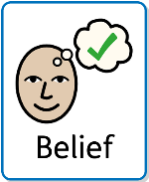  RE  Create a piece of work sharing about faith and belief. This can be about you or the meaning of the words in general.  What do you believe in? | Maths  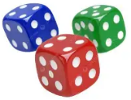  Create a game that works on mental maths. This could be times tables, number bonds, known facts etc.  What is it you are hoping people can learn from your game? | Science  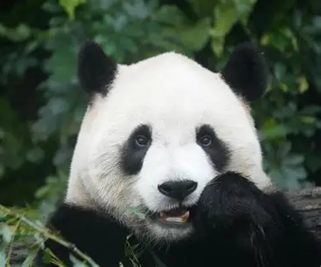  Create a model or information poster to share about a particular animal and its habitat.  Why is that animal suited to its habitat?

