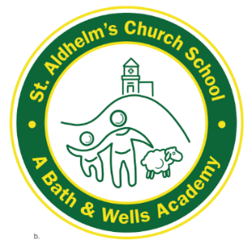
Curriculum Newsletter- Term 1
Owl Class (Year 4)
This Term, we are learning about:
English | Letters, diary entries, character and setting descriptions, non-chronological reports, dialogue, mini autobiography & fact files.
Maths | Place Value, Addition and Subtraction & Multiplication and Division.
R.E. | What do Christians believe about God?
Science | Living Things and their Habitats.
Geography | Europe: Italy and Rome.
Art | Observational drawing: Portraits.
P.E. | Yoga & Evolve Sports (2 sessions)
P.S.H.E. | Being Me in My World.
French | Les animaux (Animals)
Music | Mamma Mia!

