Dear Year 3 Owl Parents,

Welcome back to St Aldhelm’s and to Owls! I hope you have all had a lovely summer together. I am really enthusiastic about the year ahead, which will have an exciting curriculum, supported by engaged learners and parents. We have been working hard already to establish routines and expectations that will be carried throughout the year ahead.

The team
I will teach the class every day. Mrs Horton and Mrs Stainer will support and the former will be teaching the class for PPA (Planning, Preparation and Assessment) time on a Monday afternoon. I will work closely with Mrs Horton to ensure that handover planning and assessment information is shared and also that the subjects are rotated between ourselves throughout the year.

Owl projects
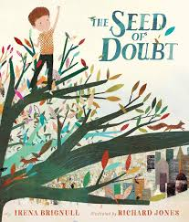
We have some great enquiry projects this year, as you will see soon on the Long-Term Plan on the class webpage. We are going to begin with ‘London- Changes Over Time’. Our English written work is going to begin with story and motivational leaflet writing, using ‘The Seed Of Doubt’ by Irena Brignull as our class book. We have already shared this book and the children have been enjoying it so far. In maths, we have started the term developing Place Value skills. This includes representing numbers in a variety of ways, alongside partitioning numbers. The children will be able to apply prior learning from last year to develop these skills further.

Uniform
It is important that the children in Owls set a good example to younger children in the school. Please ensure that your child is wearing appropriate clothing and footwear. For those children who have their ears pierced, these need to be plain studs which will need to be removed or covered with tape for PE lessons. The only jewellery required is a watch or medic alert bracelet. Children with longer hair should have their hair tied back. There is more information on the school website regarding uniform should you need to check further.

PE

Owls will have PE on a Tuesday and Wednesday and our first two PE topics will be ‘Yoga’ and ‘Personal Challenges’. The children will need to wear their school PE kit to school for these days (plain white t shirt, black PE shorts and black daps). Sometimes we may have these PE lessons outside if the weather allows, so please also provide a dark coloured track suit or dark joggers and a sweatshirt. We will aim to use the outdoors in our learning throughout the year so please could children also bring a pair of wellies to be kept in school, and a coat.

Meetings
Strong communication and links are important and valued within our school community. Class Dojo messages, emails and messages through the school office are the main ways of maintaining these strong links and communications. This ensures that I can focus on maintaining the safety of the children at the end of the school day and through transitional periods. Phone calls or meetings can be arranged should you wish to discuss an issue, concern or enquiry further and I will be happy to do so at a convenient time for both parties.

Home learning
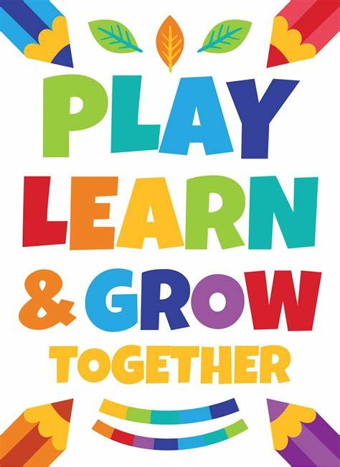
I am looking forward to establishing a strong partnership between us, which will result in your child’s learning journey being successful. It is strongly encouraged that you support your child at home by practicing reading, spelling, maths and enquiry skills. Your support at home is vital in making a difference to your child’s development. Home learning will be set each week, unless otherwise stated, on a Wednesday and will need to be completed and shared by the following Tuesday.
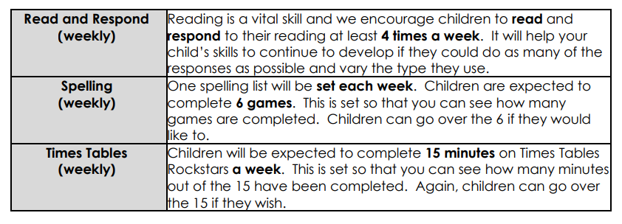

I am looking forward to meeting you at our Welcome Meeting on Thursday 11th September and I thank you in advance for your support and participation.

Kind regards,
Mr Mike Powell

